SIMATS ENGINEERING
ASSESSMENT TOOL 2
COURSE NAME: INTERNET PROGRAMMING
COURSE CODE: CSA4305
COURSE OUTCOME COVERED
CO4: Formulate data-driven web solutions using XML, XSLT, and JSP within the MVC framework. (L4)
Assessment Tool: Pseudocode Writing Task (Algorithm Design)
Weightage: 20%
QUESTIONS: Total Marks: 25
1: XML Parsing Algorithm
Write a detailed pseudocode algorithm to parse an XML document that contains structured data such as user or product details. Your algorithm should clearly describe the steps involved in loading the XML file, accessing its elements, traversing through nodes, extracting required data, and displaying the output in a readable format. Ensure that the logic handles hierarchical structure properly.
2: MVC Workflow
Write a pseudocode representation of the MVC (Model–View–Controller) workflow in a web application. Your answer should clearly illustrate how a user request is received, processed by the Controller, how the Model interacts with the database, and how the View generates and returns the response to the user. Include all major steps involved in request handling and response generation.
3: JSP Request Flow
Write a detailed pseudocode algorithm to explain the request–response flow in a JSP based web application. Your algorithm should include steps such as client request initiation, server processing, interaction with backend components (like Servlets or database), and generation of dynamic content that is sent back to the client.
4: Database Retrieval
Write a pseudocode algorithm to retrieve data from a database. Your answer should include steps for establishing a database connection, executing SQL queries, processing the result set, and displaying the retrieved data. Clearly represent the sequence of operations involved in database interaction.
5: PHP Validation
Write a pseudocode algorithm for validating user input in a web form using PHP concepts. The algorithm should include checks for empty fields, validation of input formats (such as email and password), handling invalid inputs with appropriate error messages, and allowing submission only when all validations are satisfied.
Code of Conduct:
I B.Vishnu Vardhan(192311267) (Name / Reg No) certify that this submission is my original work and that I have adhered to the guidelines specified for this assessment. I understand that any violation of academic integrity rules will result in disciplinary action.
Signature of the student:
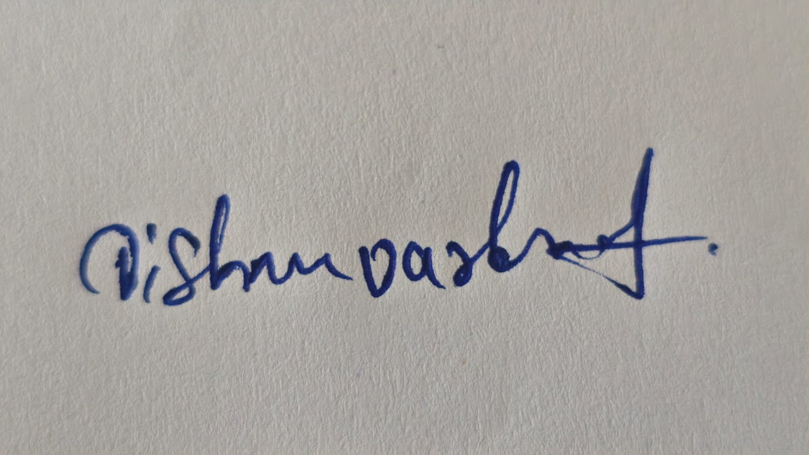
RUBRICS FOR CALCULATION:
Criteria | Weightage | Level 4 –  Exemplary | Level 3 –  Proficient | Level 2 –  Developing | Level 1 –  Beginning
Problem  Understanding | 20% | Identifies all inputs, outputs, constraints accurately | Minor missing  elements | Partial  understanding | Incorrect  interpretation
Algorithm  Design | 30% | Complete, correct, and logically sound solution | Minor logical  gaps | Partially correct logic | Incorrect  approach
Use of Control Structures | 20% | Efficient and  appropriate use of loops, conditions, functions/modules | Minor  inefficiencies | Limited or basic usage | Incorrect or  missing  constructs
Pseudocode  Structure | 10% | Well-structured,  clear, consistent format, easy to  follow | Mostly clear with minor issues | Difficult to  follow in parts | Poorly  structured and unclear

1: XML Parsing Algorithm
Pseudocode:
import javax.xml.parsers.*;
import org.w3c.dom.*;
import java.io.*;
public class Main {
public static void main(String[] args) throws Exception {
String xml = """
<products>
<product>
<id>101</id>
<name>Laptop</name>
<price>55000</price>
</product>
<product>
<id>102</id>
<name>Phone</name>
<price>30000</price>
</product>
</products>
""";
DocumentBuilderFactory f = DocumentBuilderFactory.newInstance(); DocumentBuilder b = f.newDocumentBuilder();
Document doc = b.parse(
new ByteArrayInputStream(xml.getBytes())
);
NodeList products = doc.getElementsByTagName("product"); System.out.println("Product Details");
for (int i = 0; i < products.getLength(); i++) {
Element p = (Element) products.item(i);
String id = p.getElementsByTagName("id")
.item(0).getTextContent();
String name = p.getElementsByTagName("name") .item(0).getTextContent();
String price = p.getElementsByTagName("price") .item(0).getTextContent();
System.out.println("ID: " + id);
System.out.println("Name: " + name);
System.out.println("Price: " + price);
System.out.println();
}
}
}
Output:
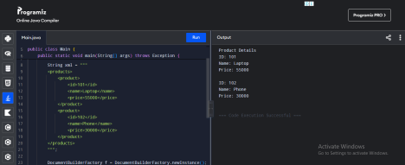2: MVC Workflow
Pseudocode:
public class Main {
// Model
static class StudentModel {
String getStudentName() {
return "Ram";
}
}
// View
static class StudentView {
void display(String name) {
System.out.println("Student Details");
System.out.println("Name: " + name);
}
}
// Controller
static class StudentController {
StudentModel model;
StudentView view;
StudentController(StudentModel model, StudentView view) { this.model = model;
this.view = view;
}
void processRequest() {
System.out.println("Request received by Controller"); String name = model.getStudentName();
System.out.println("Model processed the request"); view.display(name);
System.out.println("Response sent to User"); }
}
public static void main(String[] args) {
StudentModel model = new StudentModel();
StudentView view = new StudentView();
StudentController controller =
new StudentController(model, view);
controller.processRequest();
}
}
Output:
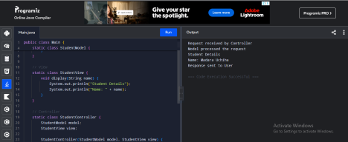3: JSP Request Flow
Pseudocode:
public class Main {
static class Database {
static String getData() {
return "Welcome to the Student Portal";
}
}
static class Servlet {
static String processRequest() {
System.out.println("Servlet processing request..."); return Database.getData();
}
}
static class JSP {
static void generateResponse(String data) { System.out.println("JSP generating dynamic content..."); System.out.println("Response: " + data);
}
}
public static void main(String[] args) {
System.out.println("Client sends JSP request"); String data = Servlet.processRequest();
JSP.generateResponse(data);
System.out.println("Response sent to Client"); }
}
Output:
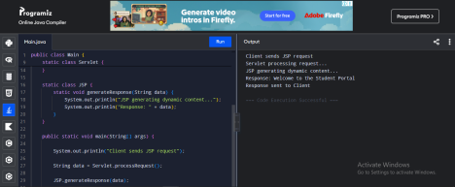4: Database Retrieval
Pseudocode:
public class Main {
static String[][] database = {
{"101", "Laptop", "55000"},
{"102", "Phone", "30000"},
{"103", "Tablet", "25000"}
};
public static void main(String[] args) {
System.out.println("Database Connected");
System.out.println("Executing SELECT Query...\n");
System.out.println("ID\tProduct\tPrice");
for(String[] row : database) {
System.out.println(
row[0] + "\t" +
row[1] + "\t" +
row[2]
);
}
System.out.println("\nData Retrieved Successfully");
System.out.println("Database Connection Closed");
}
}
Output:
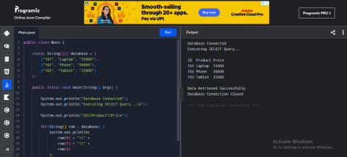
5: PHP Validation
Pseudocode:
<?php
$name = "Ram";
$email = "Ram@gmail.com";
$password = "Pass1234";
$errors = [];
if (empty($name))
$errors[] = "Name is required";
if (!filter_var($email, FILTER_VALIDATE_EMAIL)) $errors[] = "Invalid email";
if (strlen($password) < 6)
$errors[] = "Password must contain at least 6 characters";
if (empty($errors)) {
echo "Validation Successful<br>";
echo "Form submitted successfully";
} else {
echo "Validation Failed<br>";
foreach ($errors as $error)
echo $error . "<br>";
}
?>
Output:
